**Introduction**

Familiarise yourself with the European Soccer Database (ESD)

https://www.kaggle.com/hugomathien/soccer. You can access the tables from database with your oracle account. For example, try “select * from country”. Review the results. Note that, the tables are NOT in your tables list – this is because they are technically synonyms – you are actually accessing the tables which are stored somewhere else in the database. This means you can’t actually see the tables from the SQL developer GUI. To see all the attributes, you can run the following query (normally you could use DESC as in the lectures, but due to a bug, this doesn’t work for synonyms) select column_name, data_type, data_length, nullable from all_tab_columns@fostlive where table_name = 'TABLE_NAME_IN_CAPS';

e.g.

select column_name, data_type, data_length, nullable from all_tab_columns@fostlive where

table_name = 'TEAM_ATTRIBUTES';

Check the number of rows in each table, and make sure that they match with what is specified at

ESD website.

Tasks

--1. ERD+RS (Submit the ERD and the Relational Schema

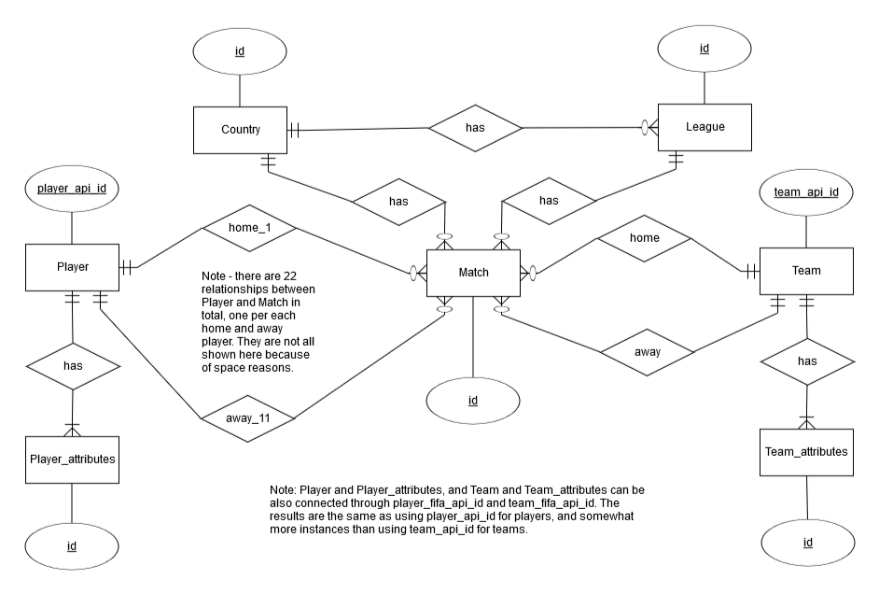

**Relational schema**

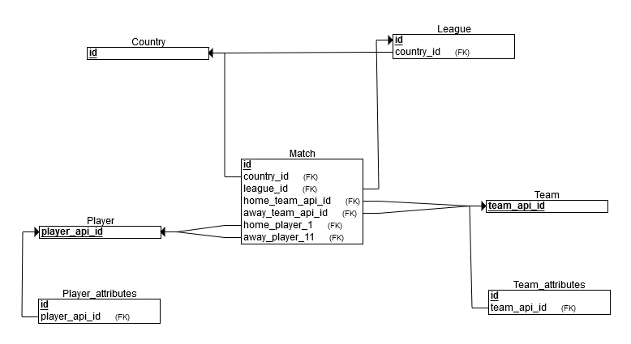

--2. List all the player_attributes of player Id 163222. 1 mark

select * from player_attributes where id = '163222';

--3. List all the player names which have a letter X in their name. 1 mark

Select player_name from player where player_name like '%x%' or player_name like '%X%';

--4. Count the matches with more than 6 goals scored. 1 mark

select count(ID) as matches from match where (home_team_goal + away_team_goal) > 6;

--5. Count the matches with more than 6 goals scored and a draw result.

select count(ID) as matches from match where (home_team_goal + away_team_goal) > 6 and home_team_goal = away_team_goal;

--6. What is league name for each country? 1 mark

select a.name as CountryName, b.name as LeagueName

from country a join league b

on a.id = b.country_id;

--7. Count all the matches from England. Use a join, rather than manually looking up England id. 1 mark

Select count(*) from match m join country c on m.country_id = c.id

where c.name = 'England';

--8. Count all of matches from Bundesliga. Use a join, rather than manually looking up Bundesliga id. 1 mark

Select count(*) from match m join country c on m.country_id = c.id join league l on l.country_id = c.id

where l.name like '%Bundesliga%';

--9. List the match with the maximum amount of goals. 1 mark

select * from match where ( home_team_goal + away_team_goal ) = ( select max( home_team_goal + away_team_goal ) from match where match.id = id );

--10. List the matches with the maximum amount of goals per country. 1 mark

Select c.name Country, m.id Match, ( home_team_goal + away_team_goal ) MaxGoals from match m join country c on m.country_id = c.id

where ( home_team_goal + away_team_goal ) = ( select max( home_team_goal + away_team_goal ) from match where country_id = c.id) ;

--11. List all of the players which have played in Switzerland League. 1 mark

Select p.id, player_name from player p where exists ( select * from match m join league l on l.id = m.league_id where l.name like '%Switzerland%'

and p.player_api_id in ( m.home_player_1, m.home_player_2, m.home_player_3, m.home_player_4, m.home_player_5, m.home_player_6, m.home_player_7, m.home_player_8, m.home_player_9, m.home_player_10, m.home_player_11,

m.away_player_1, m.away_player_2, m.away_player_3, m.away_player_4, m.away_player_5, m.away_player_6, m.away_player_7, m.away_player_8, m.away_player_9, m.away_player_10, m.away_player_11 ) )

order by player_name ;